**1.Introducion**

**1.1 Overview**

I can select a resume template it can be given by project. Next can change the name,date of birth, address, phone number,Email id and website. Next I can change the social media , the twitter is given but I can change it instagram. Then, I can change the given year and university name. I can change skills, website and multimedia.Then last I can change a colour of the image.

**1.2 Purpose**

Grabs the attention of the employers and recruiters.

Shows how you’re a match for a position or project.

**2.Problem Definition & Design Thinking**

**2.1 Empathy map**

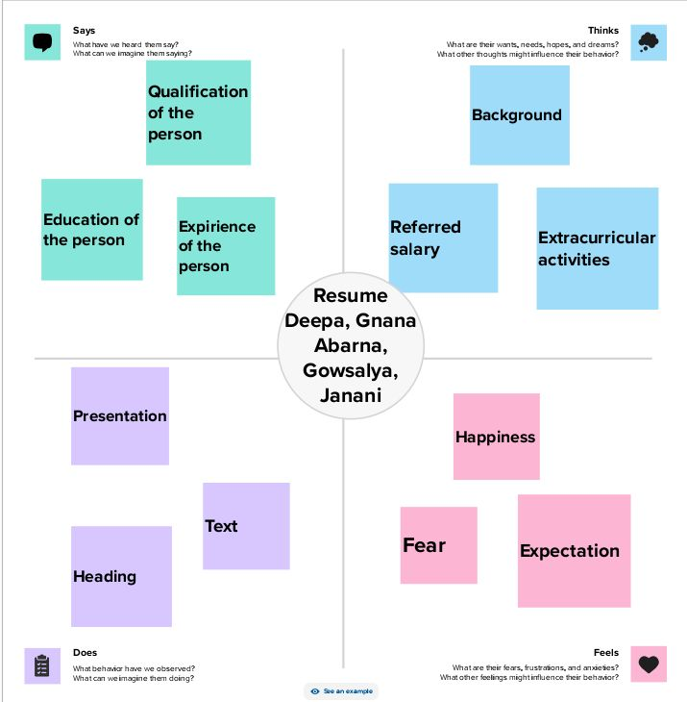

**2.2 Ideation &Brainstorm map**

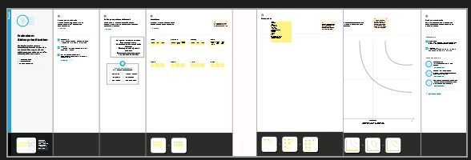

**3.Result**

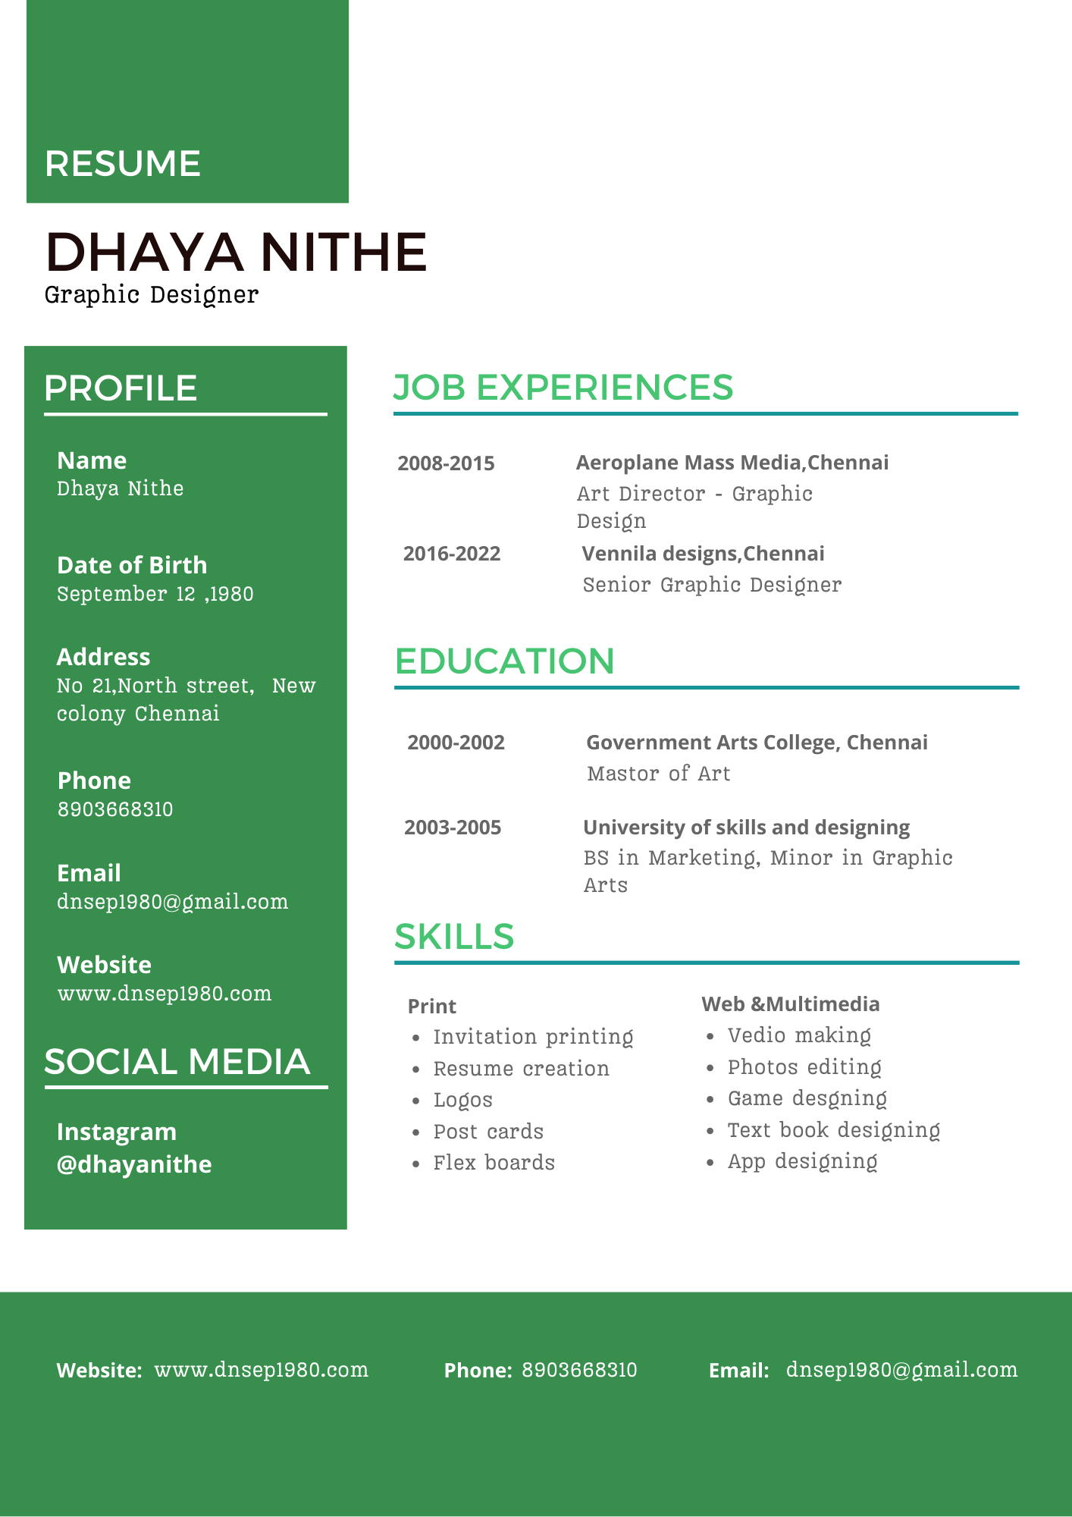

**4. Advantages & Disadvantages**

**\*Advantages**: Open door to more career opurtunities.

Showcases of strengths and achievements

**\*Disadvantages**: Emphasizes gaps in jobs.

Points out career setbacks.

**5. Applications**

Soft skills(being responsible)

Hard skills(reaserch and writing)

**6.Conclusion**

We learn how to make a convincing graphic designer resume with our guide.

We learn how to design a projects.